ABT Smart Home System

Angel Renteria

Brandon Tran

CS 122A Fall 2019

**Phase I** **2**

Introduction 2

Components (Pin-out) 3

Block Diagram 4

Partners 5

[**Phase II**](https://docs.google.com/document/d/1pa_53JlfR2dOdavLl0R0B6CPiFNPaIFuxb-KLXf-vb0/edit#heading=h.xits4jyotrzf) **6**

[Milestones](https://docs.google.com/document/d/1pa_53JlfR2dOdavLl0R0B6CPiFNPaIFuxb-KLXf-vb0/edit#heading=h.jszcwileq7sg) 6

[Milestone I](https://docs.google.com/document/d/1pa_53JlfR2dOdavLl0R0B6CPiFNPaIFuxb-KLXf-vb0/edit#heading=h.7buq6x52rlkj) 6

[Milestone II](https://docs.google.com/document/d/1pa_53JlfR2dOdavLl0R0B6CPiFNPaIFuxb-KLXf-vb0/edit#heading=h.mjsoaryhfzg0) 6

[Testing and Verification](https://docs.google.com/document/d/1pa_53JlfR2dOdavLl0R0B6CPiFNPaIFuxb-KLXf-vb0/edit#heading=h.7bmst9kpx9dg) 7

[Form Factor](https://docs.google.com/document/d/1pa_53JlfR2dOdavLl0R0B6CPiFNPaIFuxb-KLXf-vb0/edit#heading=h.nhkqagrqwse8) 8

# Phase I

# Introduction

We decided on creating a smart home system as a way of being able to implement a variety of wireless communication methods within our project. The idea of creating a smart home system was interesting in the sense that their are a variety of different components that make up a smart home. In this sense we can really implement the techniques and methods of communication that have been shown in class, and put them into practice. Along with being able to work outside of our comfort zone by introducing new technologies that we have not worked with previously.

As explained above the smart home system for our project will compose of a few different components. Firstly, the smart home system should allow for motion detection sensors to trigger lights within an area of the home. The motion detectors will communicate using Zigbee to create an area network controlled by a home station. Secondly, the home station should notify you when motion is detected while away from home. This will be done via wireless communication between the home station to an application on your phone. Thirdly, we will have a TFT LCD display connected to the home base (a microcontroller) that will allow for the homeowner to control the system. This is done by displaying a menu with a variety of options such as light adjustment, connected devices, and a “find devices” option to add additional lights. Lastly, we want the lights connected to the system to be dimmable. The home station will control the level of dimness that the lights should be set to. Being a home system, it is intended to be used within the home.

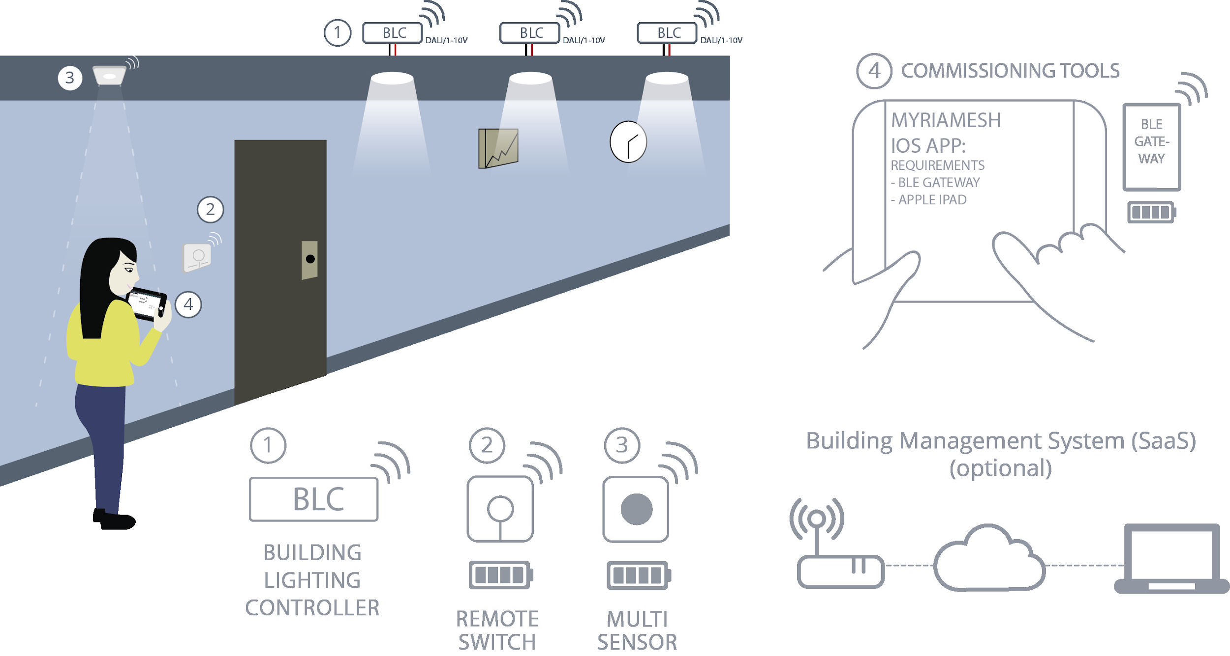

## Components (Pin-out)

* **Inputs**
  + Motion Sensors
  + XBee module
  + WiFi Module
  + TFT LCD
* **Outputs**
  + LEDs
  + XBee module
  + WiFi Module
  + TFT LCD
* **Internal components**
  + PWM IC
  + Oscillator
* **Microcontrollers/Processors**
  + Atmega 1284
  + Raspberry Pi zero W

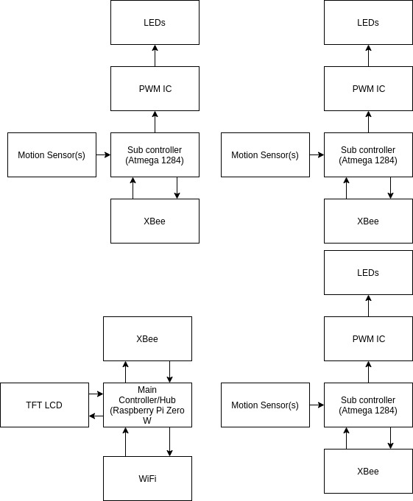

## 

## Partners

The work being done on the project will be separated in the following manner.

* The use of zigbee and motion detectors to communicate with base station
* The use of a WiFi module and the creation of a phone app to enable notifications
* Creating an interface for the base station through a TFT LCD display.
* Manipulating the brightness of LEDs through the use of PWN
* Creating a home station that will implement freeRTOS as a means of handling the various operations in the smart home system.

Angel Renteria is responsible for being able to use Zigbee to communicate to other microcontrollers, being able to use motion detection sensors, and implement the interface for the home system using the TFT LCD.

Brandon Tran is responsible for being able to use a WiFi module to send notifications to an android application that he will create, and manipulating the brightness of LEDs used in the smart home system.

The task of creating a home station using freeRTOS wll be a duty that will be tracked via GitHub cooperatively. The project as a whole will be tracked via GitHub to track progress and issues that occur during development.

# Phase II

## Milestones

### Milestone I

The system’s minimum requirements should be the following:

* A simple base station that can connect to a single microcontroller/motion detector combo.
* The base station should acknowledge that this device is connected, and receive information about motion detected in an area monitored by the sensor
* Zigbee communication should be implemented to allow intercommunication between the base station and external microcontrollers.
* The motion sensors should be able to detect movement and interrupt the atmega1284 to notify movement via a pin change interrupt.

These key features should demonstrate the necessary functionality that will be built upon for milestone II. With these features in place, other components that require these features will be easier to implement. These features will be finished and fully functioning on November 12th and will be demonstrated in lab on November 13.

### Milestone II

During our second milestone the project should implement these features

* The home base should be able to detect multiple external devices and connect with them.
* The home base can be interacted with a TFT LCD screen. The LCD screen will have a menu that can control aspects of the system such as connecting and removing devices, and displaying active devices.
* A simple android application should be implemented that can connect to the base station for future communication.
* The WiFi module should be implemented to allow for wireless communication between the base station and an android phone.

At this point in the project, the majority of the system will be implemented, however the final touches will need to be added. Each microcontroller will have a majority of their components implemented and functioning. These aspects of the project will be demonstrated on November 26.

## Testing and Verification

Testing for the project will need to involve aspects of hardware and software testing. The majority of the milestone I testing will involve hardware testing since we are unfamiliar with the components that are being implemented. Things such as the motion detectors need to signal that motion is detected and Zigbee needs to signal to other controllers to ensure a communication linelinetherethere. In terms of software the base station needs to be tested for correctness. This will be done through the use of simulated inputs using AVR-GDB for testing. This means of testing the software should guide us in how the system should interact, and provide an easier means of debugging when certain aspects aren’t functional.

During milestone II the project will see an increase of system logic to implement features such as the TFT LCD, WiFi communication, and connection of multiple devices. The software testing in this stage will be vital to ensure the system responds appropriately. Since we are implementing freeRTOS for the base station, we need to ensure that these tasks in our system receive the appropriate priority in the system. By using AVR-GDB tests will be able to simulate vital cases in the system that could be problematic during its operation.

When it comes to external testers, the need to have individuals interact with the system can demonstrate areas of interaction we never considered. In these phases of testing having other students in our lab section can provide some initial feedback on the reliability of the system. Does it work as intended? Are there bugs when certain inputs are given? These questions can be answered through this phase of alpha testing. In our beta testing phase, having input from individuals who aren’t taking the class can be useful. Someone who is unaware of the manner in which the system can operate will interact different then someone with some experience with the technology. Individuals like our housemates can be a means by which test aspects of our system for unexpected scenarios. The means by which they would interface with the system could produce results that we never considered. Allowing us to account for as many use cases as possible.

## 

## 

## Form Factor

If we were to deploy this outside of development, we would fabricate a PCB board for the sub controllers of the project. On the board would be the microcontroller, PWM, wireless modules, and the LEDs, with three wires that will lead out and connect to the motion sensor. This will be in a small case due to its smaller form factor, with holes for the outputs of the leds and for the location of the sensor. This will allow for the sub controllers to be more portable and discreet in the environment. The hub will be on its own custom PCB.